This is the abstract's title
  - And this is the (optional) subtitle
Keywords: First; Second; Third; Fourth; Fifth

Introduction
This template is edited with Word styles so, instead of formatting manually, use the styles option provided in the Styles Pane. The text for the Introduction should have a recommended length of 300 words and be kept in the Normal style (see Table 1 for further details). If you need to include italic, you should use the style Emphasis, instead of applying directly the “italic” formatting option from the button bar. Notice that the title for this section, “Introduction”, is using the Heading 1 style.
Please bear in mind that your abstract cannot exceed six pages and that the maximum number of words is 1500 (comprising Introduction, Research, Conclusion, References and/or any other Section you wish to include). Do not use double paragraph to visually separate items since this is already predefined in the provided Word styles.

Paper, Workshop, Poster, or Artwork Description
The title above should be replaced to whatever you find adequate. The abstract submitted must be written in English and refer to original papers, workshops, posters, or artworks that have not been published of presented elsewhere nor submitted to other congresses or conferences. The abstract is anonymous for double-blind peer review and any elements that may identify the abstract’s authorship or institution must be omitted. An abstract that does not comply with the rules and settings of this template will be declined.
This section should be kept in the “Normal” style. If you need to include the italic form, please use the style Emphasis. If you need to include a footnote, you may do so using Word’s own footnote function and the template will apply the appropriate style for the footnote.
References, citations, and bibliography should comply with the APA style, 7th edition. An example of a reference should be like this (Koehler, 2016, p. 45). Citations must include the page number and generally look like Sapolsy (2017, p. 32) or from that other work (Ervin et al., 2018, p. 470). More information for including in-text citations can be found here: https://apastyle.apa.org/style-grammar-guidelines/citations. You may use a bibliography manager such as Zotero or Mendeley with APA’s 7th edition or refer to https://apastyle.apa.org/style-grammar-guidelines/references/examples.
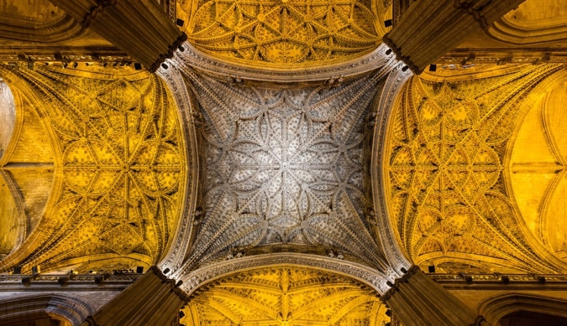
The following exemplifies the insertion of an image in Figure 1. In the caption, “Figure 1” has the paragraph style Normal with the character style Emphasis applied. Every figure should be referenced in the text as shown below. The caption must include the figure number (Figure 01, Figure 02, …) in Emphasis and the description in Normal. The figure layout text wrapping style should be “Top and Bottom” and it should be Centered in the Horizontal Alignment option. All images should be of your own authorship or should be used with a written authorization from the original author.
Figure 1. This is the vault from Seville Cathedral, retrieved from wikimedia. Diego Delso, CC BY-SA 4.0 <https://creativecommons.org/licenses/by-sa/4.0>, via Wikimedia Commons.
As for tables, they should use homonymous styles and rules as figures, as exemplified in Table 1. For the general writing style, please refer to the Mechanics of Style in https:// apastyle.apa.org/style-grammar-guidelines/mechanics-style and the General Bias-Free Language, also found in https://apastyle.apa.org/style-grammar-guidelines/bias-free-language.
Table 1. Summary of formatting options used in the Styles of this document.
Style | Font Size | Line Height | Paragraph Space Before | Paragraph Space After
Title | 28 | 1.0 | 0 | 0
Subtitle | 12 | 1.0 | 0 | 18
Keywords | 9 | 1.0 | 12 | 60
Heading 1 | 16 | 1.0 | 24 | 6
Normal | 12 | 1.5 | 0 | 12
Figure Caption | 9 | 1.0 | 6 | 30
Table Caption | 9 | 1.0 | 0 | 0
Table Contents | 9 | 1.0 | 0 | 0
Header | 9 | 1.0 | 0 | 0
Footnote Text | 9 | 1.0 | 0 | 0

Overall, this section should contain around 1000 words in order to fully explain the idea of your research to the reviewers. As always, the text body should use the style Normal and paragraph quotes (40 words or more) should use the Quote style (Seymour, 1987, p. 34):
The smaller copolymer fractions moved readily into the bloodstream whence they were either lost in the urine or they gradually penetrated into other tissues and organs. Long-term (21 days) body distribution of copolymers following both intraperitoneal and subcutaneous administration showed size-dependent accumulation in organs of the reticuloendothelial system.

Conclusion
The abstract’s conclusion should not exceed 100 words, serving mainly as a synthetic recap of the subjects discussed. Mind that you will have much more possibilities to fully accommodate your fully developed research in the final paper.
The docx file must be named with the three first words of the abstract’s title (in small caps) and converted into a pdf file before being submitted through EasyChair.
After receiving the EasyChair confirmation, the corresponding author must submit a short biographical note (150 words maximum) to symmetrycongress2022@arq.up.pt, identifying the ID of his/her submission.

References
Ervin, Fernyhough, M., Kay, Sinsho (2018). Emotions in storybooks: A comparison in the United States. Psychology of Popular Media Culture, 8(3), 207–217. https://doi.org/10.1037/ppm0000185
Koehler, L. M. (2016). The psychology of prejudice: From attitudes to social action (2nd ed.). American Psychological Association. https://doi.org/10.1037/0000168-000
Sapolsky, R. M. (2017). Behave: The biology of humans at our best and worst. Penguin Books.
Seymour, J. M. (1987). Factors influencing customer satisfaction at a fast-food hamburger chain: The relationship between customer satisfaction and customer loyalty (Publication No. 10169573) [Doctoral dissertation, Wilmington University]. ProQuest Dissertations & Theses Global.

Use the button labelled “Insert Footnote” in the References tab of the Ribbon bar. Mind that the footnote should be kept in the “Footnote Text” style.

